Batch Gradient Descent with Code Demo
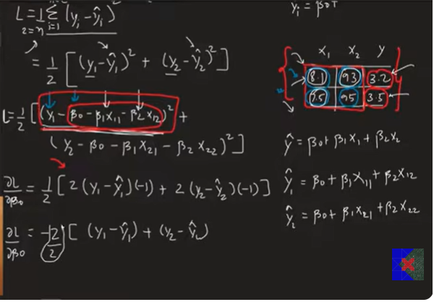
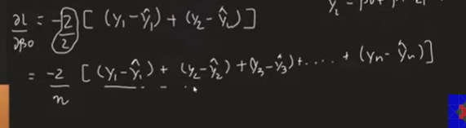
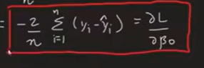

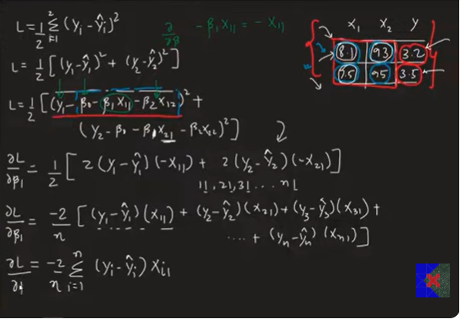
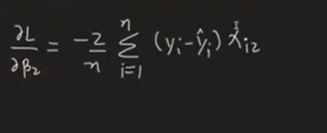
General formulae :-
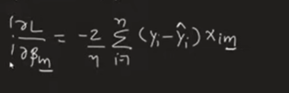

1. What is Multiple Linear Regression?
Multiple Linear Regression is used when there are two or more input features to predict one output.
Example:
- X₁ = CGPA
- X₂ = IQ
- Y = Placement Package
Unlike Simple Linear Regression (one feature), Multiple Linear Regression has multiple coefficients.

2. Multiple Linear Regression Equation
Prediction Equation
ŷ = β₀ + β₁X₁ + β₂X₂ + ... + βₙXₙ
where
- β₀ = Intercept (Bias)
- β₁, β₂, ..., βₙ = Weights (Coefficients)
- X₁, X₂, ..., Xₙ = Input Features
- ŷ = Predicted Output

3. Number of Parameters
If there are n input features, then total parameters are
n + 1
because
- 1 Intercept (β₀)
- n Weights (β₁ to βₙ)
Example:
2 Features
β₀
β₁
β₂
Total Parameters = 3

4. Objective
Find the values of
β₀
β₁
β₂
...
βₙ
that minimize the prediction error (cost function).

5. Initialization
Start with random values.
Example
β₀ = 0

β₁ = Random

β₂ = Random
or initialize all to zero.
Gradient Descent will improve these values in every iteration.

6. Prediction
For every training example,
ŷ = β₀ + β₁X₁ + β₂X₂ + ... + βₙXₙ

7. Error
Prediction Error
Error = y − ŷ
where
- y = Actual Value
- ŷ = Predicted Value

8. Cost Function (Mean Squared Error)
J(β) = (1/n) Σ (yi − ŷi)²
where
- J = Cost Function
- n = Number of Samples
Goal:
Minimize J(β)

9. Gradient
The gradient tells us how to change each parameter to reduce the cost.

Gradient for Intercept
∂J/∂β₀ = (-2/n) Σ (yi − ŷi)

Gradient for Weight
∂J/∂βⱼ = (-2/n) Σ Xij(yi − ŷi)
where
- Xij = j-th feature of the i-th sample

10. Gradient Descent Update Rule
General Formula
New Parameter = Old Parameter − Learning Rate × Gradient
or
β = β − α × Gradient
where
- β = Parameter
- α = Learning Rate

11. Update Intercept
β₀ = β₀ − α × ∂J/∂β₀

12. Update Every Weight
β₁ = β₁ − α × ∂J/∂β₁

β₂ = β₂ − α × ∂J/∂β₂

...

βₙ = βₙ − α × ∂J/∂βₙ
All coefficients are updated in every iteration.

13. Matrix Representation
Prediction
ŷ = Xβ
where
- X = Feature Matrix
- β = Weight Vector
Gradient
Gradient = (-2/n) Xᵀ(y − ŷ)
Parameter Update
β = β − α × Gradient
Using matrices makes the computation much faster for datasets with many features.

14. Gradient Descent Algorithm
Step 1:
Initialize β randomly

↓

Step 2:
Predict

ŷ = Xβ

↓

Step 3:
Calculate Error

Error = y − ŷ

↓

Step 4:
Calculate Gradient

↓

Step 5:
Update Parameters

β = β − α × Gradient

↓

Repeat until convergence

15. Learning Rate
Learning Rate controls the step size.
Small Learning Rate
α = 0.001
- Slow learning
- Stable
Large Learning Rate
α = 1
- Fast
- May overshoot
Common values
0.001
0.01
0.05
0.1

16. Why Matrix Form?
Instead of calculating every derivative separately,
we calculate all gradients together using
Xᵀ(y − ŷ)
Advantages
- Faster
- Less code
- Efficient for large datasets

17. Advantages
- Handles multiple features
- Efficient using matrix multiplication
- Scales well for large datasets
- Used in Machine Learning and Deep Learning

Important Formula Sheet (Exam)

Prediction
ŷ = β₀ + β₁X₁ + β₂X₂ + ... + βₙXₙ

Matrix Prediction
ŷ = Xβ

Cost Function
J(β) = (1/n) Σ (yi − ŷi)²

Error
Error = y − ŷ

Gradient (Intercept)
∂J/∂β₀ = (-2/n) Σ (yi − ŷi)

Gradient (Weight)
∂J/∂βⱼ = (-2/n) Σ Xij(yi − ŷi)

Matrix Gradient
Gradient = (-2/n) Xᵀ(y − ŷ)

Parameter Update
β = β − α × Gradient

Intercept Update
β₀ = β₀ − α × ∂J/∂β₀

Weight Update
βⱼ = βⱼ − α × ∂J/∂βⱼ

Learning Rate
α = Step Size

Interview Definition
Gradient Descent for Multiple Linear Regression is an optimization algorithm that minimizes the Mean Squared Error by iteratively updating the intercept and all feature coefficients in the direction opposite to the gradient until the model reaches the minimum cost.

